Asia Education Leader Forum（Summer）

Educational Changes towards a Sustainable Asia

Saturday 18 September 2021

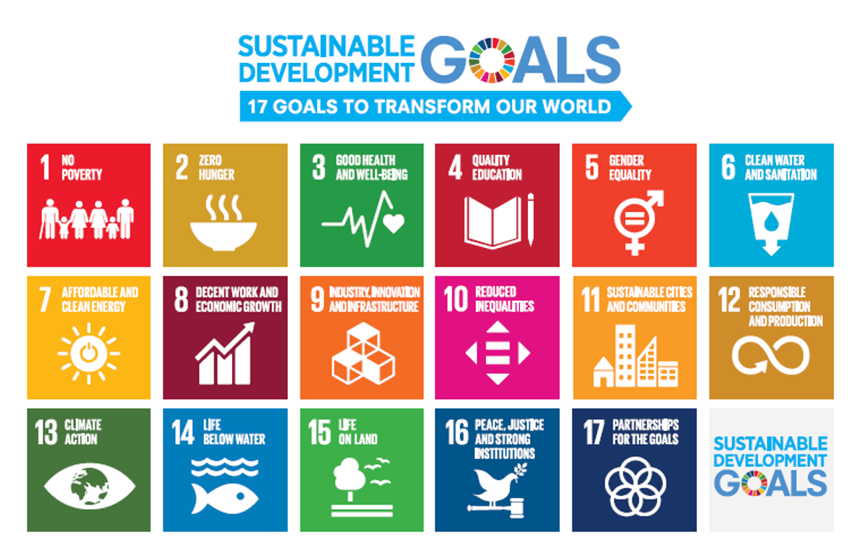

The year 2021 opened another ten years for the global society to fulfill sustainable development goals (SDGs) in 2030. Since the end of 2019, the COVID-19 pandemic has been causing unprecedented challenges to the world. Moreover, it also brought different changes in our education.

This forum aims to invite students from AELC (Asia Education Leader Course) member universities to share their research and practices in education and other relevant fields to discuss and share their understanding and insight on educational changes in Asia. It is expected to provide learners' voices in higher education to address opportunities and challenges for fulfilling SDGs by 2030.

Submissions are invited on the following themes:
- Education policy and administration
- Teaching & learning
- Education and wellbeing (Care)
- Education and innovation

ABSTRACT SUBMISSION DEADLINE: 6 September 2021.

For any inquiries, please contact AECL Coordinator at your university.

Application Form

Asia Education Leader Forum

Educational Changes towards a Sustainable Asia

- Full name of presenter (s)

- Affiliation

- Corresponding Email

- Theme (Please select one from the following four themes):
- Education policy and administration
- Teaching & learning
- Education and wellbeing (Care)
- Education and innovation

- Presentation title:

- Abstract (200 words)

